

Information Pack

Cloughwood Academy
Stones Manor Lane
Hartford
Cheshire
CW8 1NU

01606 537690
admin@cloughwood.com

Timings of the School Day

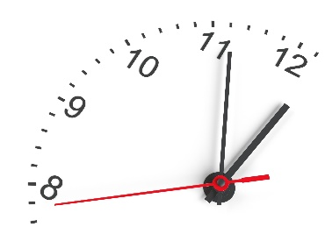

Monday to Friday
Time | Details
8:30 | Form time (15mins)
8:45 | Period 1 (50mins) (Celebration Assembly on a Friday)
9:35 | Period 2 (50mins)
10:25 | Break (30mins)
10:55 | Period 3 (50mins)
11:45 | Lunch (30mins) | Period 4 (50mins)
12:15 | Period 4 (50mins) | Period 4 (50mins)
12:35 | Period 4 (50mins) | Lunch (30mins)
13:05 | Period 5 (50mins)
13:55 | Period 6 (40mins)
14:35 | Form time
14:45 | Home time

Meet the Staff

Senior Leadership Team
R Newton | Headteacher
S Howarth | Deputy Headteacher
R McEvoy | Assistant Headteacher - Vocational
J Thomas | Assistant Headteacher - SENDCo
C Clarke | Head of Care/Pastoral Lead
L Hood | Designated Safeguarding Lead
R Whyles | School Business Manager
Safeguarding Team
L Hood | Designated Safeguarding Lead
R Newton | Deputy Safeguarding Lead
S Howarth | Deputy Safeguarding Lead
C Clarke | Deputy Safeguarding Lead
J Thomas | Deputy Safeguarding Lead
R McEvoy | Deputy Safeguarding Lead
D Cheetham | Deputy Safeguarding Lead
Teaching Staff
E Bailey | Art
I Beckett | Catering
K Beer | Horticulture / Forest School
C Chick | Humanities / Deputy SENCO
R Duval | English
C Forshaw | PE
D Harper | PSHE / PfA
K Hollins | Complex Needs Lead
S Hollister | Maths
T Chambers | Complex Needs
K Abioye | Science
T Offord | ICT
T Phillips | Upper Primary
A Rafferty | Complex Needs
M Rivett | Construction
K Bagshaw | Lower Primary
Support Staff
J Whittaker | Primary Teaching Assistant
M Brown | Catering Teaching Assistant
S Williams | Complex Needs Teaching Assistant
J Cooper | Upper primary Teaching Assistant
A Brumby | Science Teaching Assistant
L Mizon | ICT Teaching Assistant
R Lea | Horticulture Teaching Assistant
L Martin | Complex Needs Teaching Assistant
S Gittins | PE Teaching Assistant
A Swinden | Math’s Higher Level Teaching Assistant
A Jeavons | Humanities Teaching Assistant
T Jones | ICT Higher Level Teaching Assistant
L Nubley | Complex Needs Teaching Assistant
H Christie | Construction Teaching Assistant
H Mitchell | Art Teaching Assistant
D Perry | English Teaching Assistant
Residential Team
C Clarke | Head of Care
Z Dixon | Residential Support Worker
E Chikapa | Residential Support Worker
S Tilley | Residential Support Worker
D Cheetham | Senior Residential Support Worker
Administration Team
E Acton | Finance and HR
H Walker | SEND Administrator
M Spilsbury | General Enquiries / Transport / Attendance
G Thomas | Data, Exams and Admissions
Catering Team
J Kelly | Catering Assistant
S White | Catering Manager
Site Team
P Fitzsimmons | Laundress
G Prest | Site Manager

School Uniform
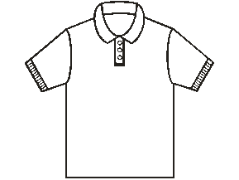
As a school we feel that it is important that pupils come to school ready to learn. Wearing the correct school uniform helps them to do this. Cloughwood Academy wishes to promote a sense of pride and belonging in our pupils and we believe that the wearing of a school uniform is one of the ways in which this can be achieved. The uniform is simple, practical and economically priced. We do not accept any fashion brands as part of school uniform, as this can be a negative distraction. We expect all pupils to be dressed the same.
Please contact the school office if you require a uniform order form.
Please ensure all items of clothing are permanently marked with your child’s name.
Our uniform is as follows:
Secondary - Year 4 to 11
Navy blue school logo Long sleeved Jacket, Navy blue school logo short sleeved T-shirt
Navy trackpants and black shoes
Sixth Form - Year 12 and 13
Pupils can wear their own clothes, but must wear appropriate PPE (provided)

School Uniform Prices

Junior |  | Adult
T-shirt  Sizes:  Chest: 28” 30” 32” 34” 38” 40” 42” 46” 48” 52”  size: 7/8 9/10 11/12 13 S M L XL XXL XXXL | £8.00 each | £10.20 each
Jacket  Sizes:  Chest: 28” 30” 32” 34” 38” 40” 42” 46” 48” 50”  Size 7/8 9/10 11/12 13 S M L XL XXL XXXL | £16.00 each | £20.00 each
Trackpants  Sizes:  Waist: 23” 24.5” 26” 27.5” 32” 34” 36” 38” 40” 42”  Size: 7/8 9/10 11/12 13 S M L XL XXL XXXL | £15.00 each | £18.00 each

The easiest way to pay for uniform is by BACS when you submit your order form.
School bank details: Account Number: 22541168 Sort Code: 30-90-16

PE kits are provided in school. All kits are freshly laundered after each use.
Pupils can bring in their own trainers for use in PE lessons.

If you have any second hand uniform that you would like to donate to school, we would be so grateful, as we can always make use of it.
School Meals



All pupils will be offered free toast and a hot drink when they arrive in school in the morning.
We also offer all pupils free fruit at morning break.
All of our school meals are freshly prepared in our school kitchen by our own in-house Catering Manager.

If you believe your child is entitled to Free School Meals, please visit the following website to alert Cheshire West & Chester that your child has moved to Cloughwood Academy.

www.cheshirewestandchester.gov.uk/residents/education-and-learning/free-school-meals

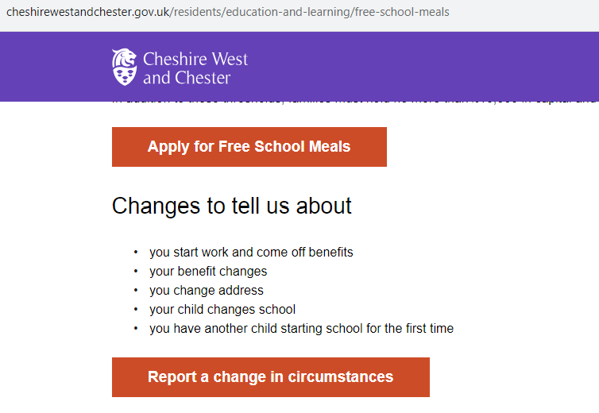

If you pay for school meals, the cost of a school meal is £2.50 for Secondary and £2.30 for Primary.

Pupils can decide on a daily basis whether they would like a school meal or to bring in a packed lunch from home. If your child would like to bring a packed lunch, we ask that it does not contain nuts, chocolate, sweets or fizzy drinks.

Families who pay for school lunches will receive a text message each Friday to confirm the school meal balance owed. We ask that the school meal balance owed is paid on a weekly basis. The easiest way to pay for school meals is by BACS.

School bank details: Account Number: 22541168 Sort Code: 30-90-16

Please see an example of our delicious School Meal Menu on the next page

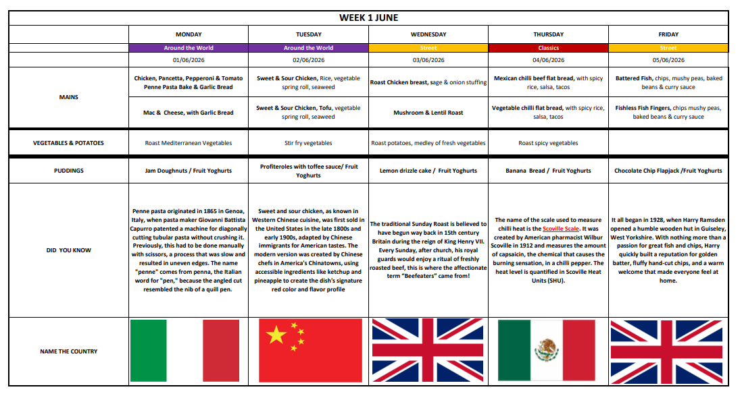
Holiday Dates
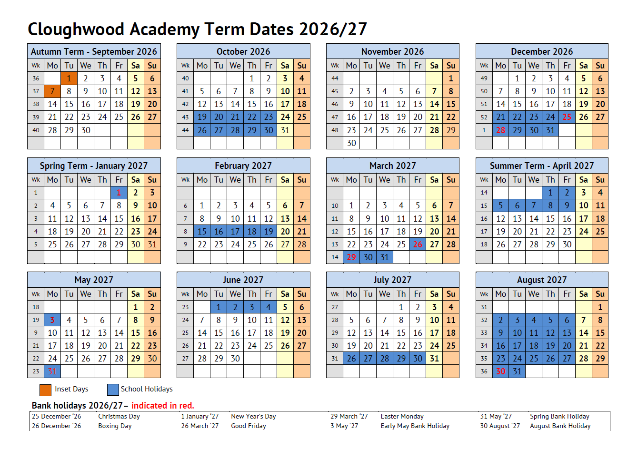
Social Media




Please follow us on our Instagram page:

cloughwood_academy

and our Facebook page:

https://www.facebook.com/CloughwoodAcademyOfficial/

This is where we share with you, lots of the day-to-day happenings here at Cloughwood Academy.

ICT Acceptable Use Agreement

The school has installed computers and Internet access to help our learning. These rules will keep everyone safe and help us be fair to others.

- I will only use ICT systems in school, including the internet, e-mail, digital video, and mobile technologies for school purposes. All use is monitored.
- I understand that the school’s ICT Acceptable Use policy has been drawn up to protect all parties – pupils, staff, visitors and the school. The policy is available on our website.
- I will only use my school e-mail address when e-mailing from school.
- I will only open e-mail attachments from people I know, or who my teacher has approved.
- I will not tell other people my ICT passwords.
- I will only open/delete my own files.
- I will be responsible for my behaviour when using ICT because I know that these rules are to keep me safe and ensure all my contact with other children and adults is responsible, polite and sensible.
- I will not deliberately look for, save or send anything that could be unpleasant or nasty. If I accidentally find anything like this, I will tell my teacher immediately.
- I will not give out my own/others’ details such as name, phone number or home address. I will not arrange to meet someone or send my image unless this is part of a school project approved by my teacher and a responsible adult comes with me.
- I will support the school approach to online safety and not deliberately upload or add any images, video, sounds or text that could upset any member of the school community.
- I know that my use of ICT can be checked, and my parent/carer contacted if a member of school staff is concerned about my safety.
- I will not sign up for any online service unless this is an agreed part of a school project approved by my teacher.
- I will not bring in memory pens or CDs into school unless I have permission.
- I will ensure that my online activity, both in school and outside school is in accordance with the law. I will not cause my school, the staff, pupils or others distress or bring the school community into disrepute, including through uploads of images, video, sounds or texts.

Remote Learning Guidelines:

- I will respect the interactions and behave respectfully towards teachers and other pupils.
- I will be appropriately dressed for learning.
- I will not record or take photos of classmates or teachers during face-to-face sessions.
- I understand that when using Google Classroom and other applications provided by the school that my use may be monitored and logged and can be made available to my teachers.
- I will not use video conferencing when in my bedroom unless arrangements have been made with a member of the Senior Leadership Team.
- I understand that these rules are designed to keep me safe and if they are not followed, school sanctions will be applied, and my parents may be contacted.
- I must leave Google Meet when instructed to by the teacher and before the teacher closes the meeting.
- I understand there must be a minimum of 3 pupils in any video conference unless arrangements have been made with a member of the Senior Leadership Team.

Attendance Reporting Procedures

Below are Cloughwood Academy’s absence reporting procedures. Please ensure you read these carefully and follow if your child is going to be absent from school. Please also refer to our newly updated (in line the new DFE statutory requirements re attendance) school attendance policy and the NHS- ‘Is my child too ill for school?’, guidelines, which can be found on the school website.

- As stated in our Attendance and Punctuality Policy, if a child is absent, the parents/carers should inform the school on the first day of absence, and each following day of absence, stating the reason by 9:00am. You can do this by calling our attendance line on 01606 537690.

- The school office will contact home when a child is absent, and the parent/carer has not notified the school of the absence. If no contact can be achieved or the reason for absence is not accepted the absence will be recorded as unauthorised. If no contact can be made after day 2, a possible unannounced home visit will take place.

- In the cases of illness please inform us of the reason for illness and follow the NHS guidelines ‘Is my child too ill for school?’ which can be found on the school website, to determine if your child can attend school or not and if not, how long they need to stay at home for.

- Pre-planned absences in the cases of Medical appointments/Funerals/Holidays (authorised/unauthorised)/ exceptional circumstances should all be reported with as much notice as possible via the school office NOT through the form tutors. A Leave of absence request form will need to be collected from the office and the completed form returned. You will then be notified if the time requested has been authorised or not.

- All medical appointments where possible should be made outside of school hours, i.e. half term. If a medical appointment is during the morning or afternoon, we expect children to attend school around (before/after) their appointment. If this cannot be achieved the pupil will be marked unauthorised for the part of the day, they can be in school but aren’t.

- After 10 sessions (5 days) of unauthorised absence your child will be placed on an attendance monitoring period of 20 days, during this time if any further absences occur you will be required to attend an absence meeting. You may also receive a fixed penalty notice warning.

- If there is anything that you feel the school should be aware of, or that we can support you with, we would be grateful if you could telephone us at school to discuss this further.

Attendance

At Cloughwood Academy, we aim to build a working relationship between ourselves and families to ensure that every child has an equal opportunity to learn – A full copy of our Attendance Policy is available on our website.
We believe that if pupils are to gain the greatest benefit from their time at school, it is essential that they attend regularly. Many parents may not realise the effect that absence or lateness has on their children. Any child who misses school runs a serious risk of being left behind in their progress.

“Twenty days off per school year means a child has about 90% attendance and will probably obtain a grade lower than they are capable of” (DfE)

Education is important
Pupils should be at school, on time and ready to learn, every day the school is open, unless the reason for absence is unavoidable. All research shows that pupils who attend well achieve well.
It is the expectation of the school that all pupils will achieve at least 98% attendance. There are a variety of reasons for pupils missing school. Some are unavoidable but we would ask that you support us in ensuring that your child’s attendance meets both the school and the government’s expectations.
Any problems with regular attendance, especially any concerns about personal issues or learning difficulties are best sorted out by the school, the parents/carers and the student at an early stage. We closely monitor your child’s attendance and will contact you if we feel there is an issue. The school undertakes a wide range of measures to support pupils where attendance at school is an issue.
If you have any concerns about your child’s attendance or wish to speak to us regarding any issues, please arrange a meeting with your child’s form tutor in the first instance.

Regular attendance at school is the responsibility of parents and carers.
Under the 1996 Education Act parents commit an offence if their child does not attend school regularly.
If your child cannot come to school because of illness, you should advise the school on each morning of absence by telephone or email:

Telephone: 01606 537690 and choose option 001 or Email: admin@cloughwood.com

If no message is received, we will assume that your child is absent without your permission. We will contact you to request information regarding their absence. For this reason, it is essential that the school is kept informed of changes of contact details such as phone numbers and addresses. Any absences where a reason is not supplied will be marked as unauthorised.
In cases of continuous absence and where we have reasons to be concerned, we may make a ‘home visit’.

Privacy Notice

We, Cloughwood Academy, are the Data Controller for the purposes of the Data Protection Act. We collect information from you and your child and may receive information from your child’s previous school and other agencies. We hold this personal data and use it to:

- Support teaching and learning
- Monitor and report on progress
- Provide appropriate pastoral care, and
- Assess how well your child is doing

This information includes contact details, national curriculum assessment results, attendance information and personal characteristics such as ethnic group, special educational needs and any relevant medical information. If your child is enrolling for post 14 qualifications, we will be provided with their Unique Learner Number (ULN) by the Learning Records Service and may also obtain from them details of any learning or qualifications undertaken.

We will not give any information to anyone outside the school without your consent unless the law requires us to do so. We may pass on personal information for child protection reasons or to other relevant agencies or partners.
We are required by law to pass some information to the Department for Education (DfE) and, in turn, this will be available for the use(s) of the Local Authority.
If you want to see a copy of the information we hold and share, then please contact the academy office.
If you require more information about how the Local Authority (LA) and/or DfE store and use the information, then please go to the following websites:

www.cheshirewestandchester.gov.uk
https://www.gov.uk/guidance/data-protection-how-we-collect-and-share-research-data

If you are unable to access these websites, please contact the LA or DfE as follows:

Public Communications Unit Department for Education Sanctuary Buildings Great Smith Street London SW1P 3BT website:http://www.education.gov.uk/ email:http://www.education.gov.uk/help/contactus tel: 0370 000 2288 The Data Protection Officer Cheshire West and Chester Council HQ 58 Nicholas Street Chester Cheshire CH1 2NP email: FOIWest@cheshirewestandchester.gov.uk tel: 0300 123 8 123

In addition, for Secondary Schools:
Once your child is aged 13 or over, we are required to pass on certain information to providers of youth support services in your area. This is the local authority support service for young people aged 13 to 19 in England. We must provide your address and that of your child, together with their name and date of birth and any further information relevant to the support services’ role. However, you or your child (if they are over 16) can ask that no information beyond their name, address, date of birth and your address, be passed to the support service. Please inform the academy office if you wish to opt-out of this arrangement. For more information about young peoples’ services, please go to the National Careers Service page at https://nationalcareersservice.direct.gov.uk/aboutus/Pages/default.aspx i Attendance information is not collected for pupils under 4 at Early Years Settings or Maintained School.
How to make a complaint

Many concerns and minor complaints can be resolved quickly and informally. There are many occasions where issues are resolved immediately through the class teacher or another member of staff, depending upon the nature of the complaint.

If you as a parent / carer have a complaint concerning the welfare of your son in Cloughwood Academy, you should immediately register your complaint with the Headteacher or with a senior member of staff available.

If you are dissatisfied with the response, please follow the Complaints procedure on our website under the About Us / Policies section.

